**RIPHAH INTERNATIONAL UNIVERSITY ISLAMABAD**



**Bachelor of Computer Science – 5th Semester**

**Subject: OS Lab**

**Submitted to: MS. Kasur**

**Submitted by: Faareha Raza Qadri**

**Sap ID: 47431**

**Lab Task**

**Q1.** To begin, you need to set up a structured directory layout in your home directory. Start by creating two directories named **OS_Course** and **OS_Lab**. These directories will serve as the main folders for organizing your OS Lab tasks. After creating these directories, switch to the **OS_Lab** directory. Within OS_Lab, create three more directories named **LAB_Class_Task, LAB_Activities, and Lab_Practice**. Each of these directories will help you categorize different aspects of your lab work. Once you have created these directories, go into the **Lab_Practice** directory and create a file named example.cpp. This file should be empty and will be used for practice later. Finally, move back to your home directory. Make sure to take screenshots of each step, including the creation of directories, the file creation, and your navigation commands to document your process.

**Note:** Include screenshots, where required to illustrate your explanation.

**Solution:**

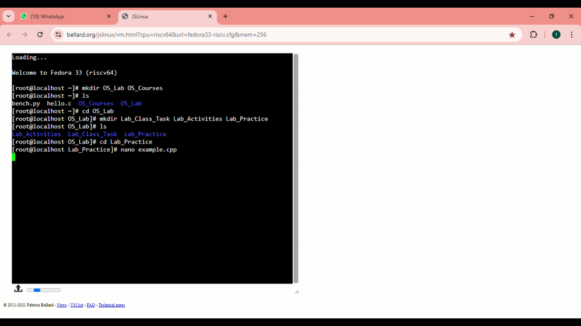

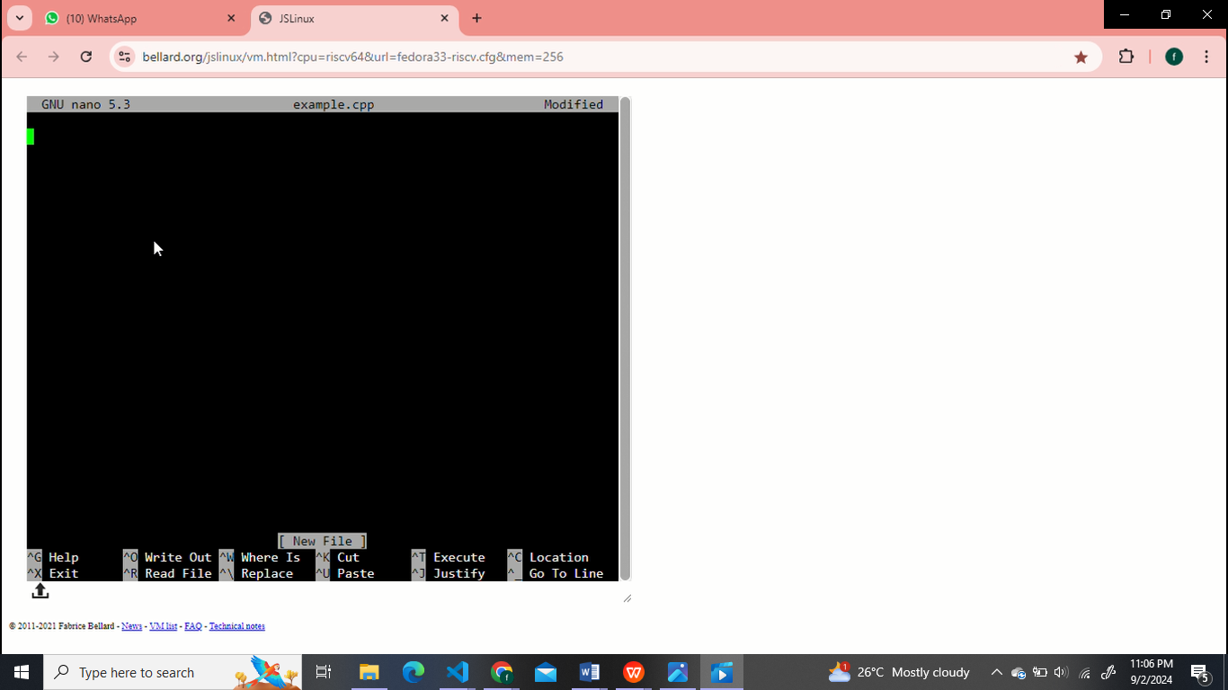

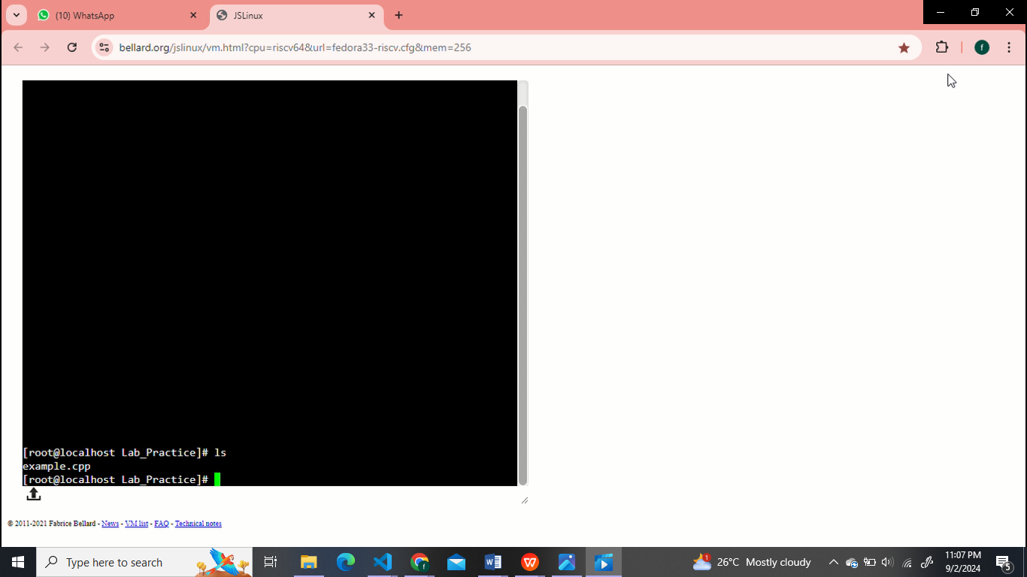

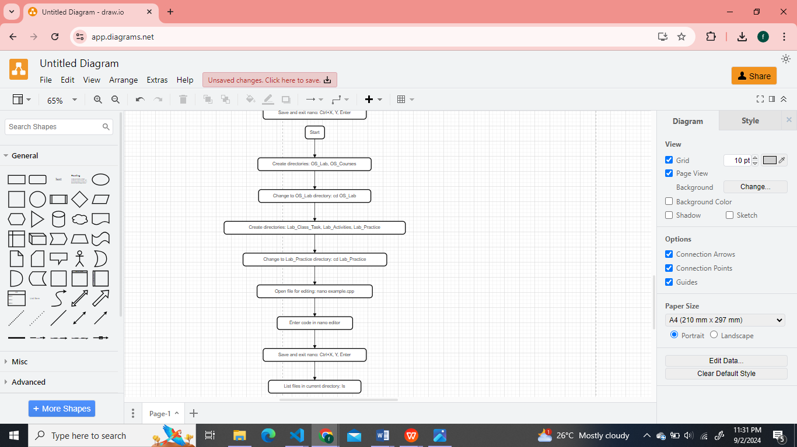

**Q2.** Finally, you need to understand the concepts of absolute and relative paths. Explain the difference between these two types of paths and provide an example of each. This will help you navigate directories more effectively. If you are currently in the Lab_Practice directory, describe the relative path to access the **LAB_Activities** directory. This will test your understanding of how to move between directories using relative paths.

**Note:** Include screenshots, where required to illustrate your explanation.

**Solution:**

**Absolute Path**

The path that describes the location of a file starting from the root, right through to the specific file.

**Example:**

Linux: /home/user/documents/Faareha.txt

Windows: C:\\Users\\User\\Documents\\Faareha.txt

**Relative Path**

It is the path showing where the needed file or folder is situated in relation to the current working directory.

**Example:**

Linux: documents/Faareha.txt if the current directory is /home/user.

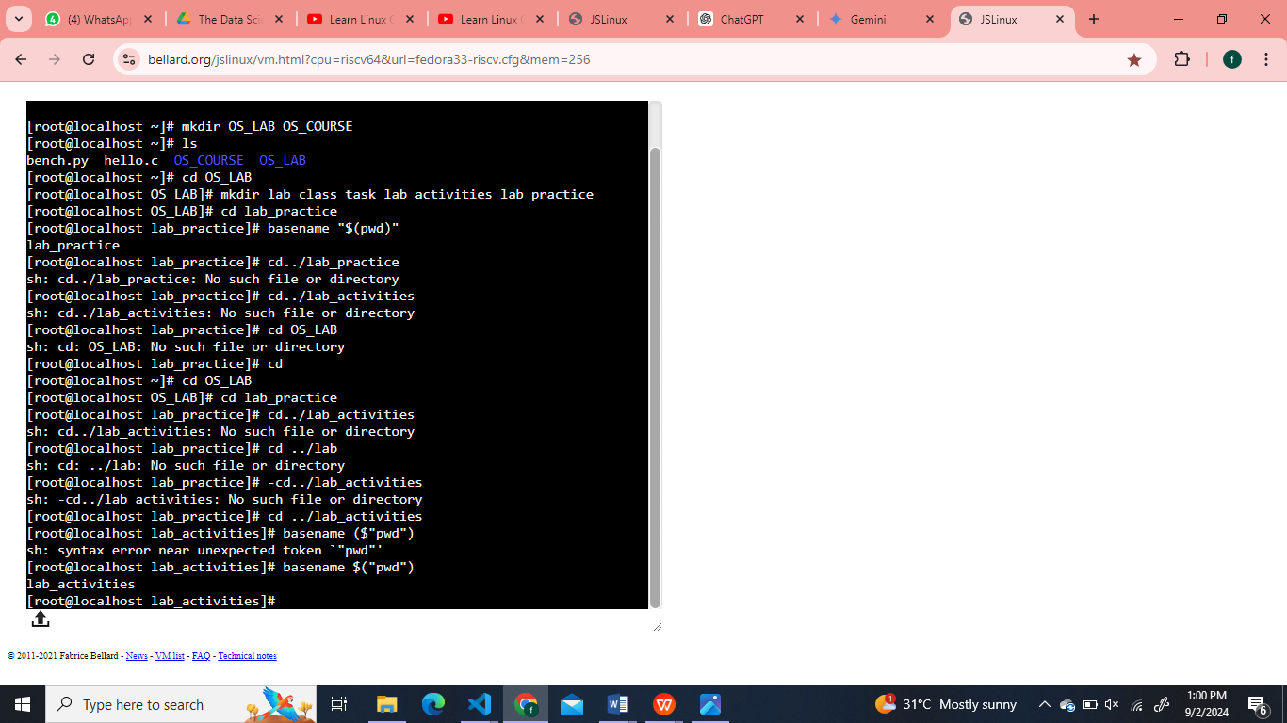

**Q3.** Imagine you’re working on your computer when you suddenly need to turn it off quickly. You press and hold the power button until the computer shuts down completely. After an hour, you turn the computer back on, and it quickly shows the login screen or desktop.

Why does your computer start up smoothly and quickly after being turned off? Describe the process that happens between powering off the computer and seeing the login or desktop screen. What steps does the computer go through to get everything ready in a short amount of time?

**Solution:**

Once you power on the computer:

**1.** **Power On:** The power supply sends electricity to the motherboard and components.

**2.** **BIOS Initialization:** The BIOS firmware starts up, initializes, and checks hardware components.

**3.** **POST**: The BIOS does a Power-On Self-Test to make sure all the hardware are functioning correctly.

**4.** **Loading Bootloader**: Bootloader initiates the loading of kernel of the OS into the memory.

**5.** **OS boots up**: OS boots up this stage involves the loading of the drivers, service, and the user interface into the memory.

**6.** Providing Login to User in the forms of Login screen is displayed for the system to login with access to your desktop.